Serials: Difficulty level Medium
Background:
In our current system we have created our own version of a serials module by using a second item record as holdings record. We create circulating record to manage checkouts to patrons, but there is no management at a higher level of the publication, subscription or expectation of delivery. Our Sierra Success Bundle includes a module that is designed to manage the unique nuances of serials, from their bibliographic information, publication frequency, coverage and transactions. Currently, our patrons are able to see the holdings statement only.
Sierra contains various functions to maintain and manage your library's serials, including:
- Journals, periodicals, and newspapers
- Government documents
- Monographic series Sierra supports:
- Standard and special serials, including advance sheets, supplements, cumulations, reprints, microform reproductions, indexes, etc.
- Spine labels and pocket parts
- All frequencies (regular and irregular)
Serials records are called “Checkin Records”. They are more complex than an item record and include tabs for storing the following information:
- Summary tab: View a summary list of all Holdings records attached to the bib
- Record tab: Displays the Checkin record includes the fixed-length and variable-length fields associated with the selected Checkin record.
- Card tab: Displays the Checkin card for the record. Contains boxes for each individual issue of that serial
- Holdings tab: Displays holdings information (the volumes or issues in the collection)
- Routing tab: Lists the individuals to whom this serial is routinely routed (optional)
- Bib-level holds tab: place or view holds for that particular item
Manages Subscriptions
- Each Checkin Record includes a checkin card. When the record is created the frequency is used to create the expected cadence of arriving issues. When the copy arrives, the staff use the check in record in the holding statement to “Receive” the copy and create the item record. The checkin card sets up the expectation for fulfillment. Information on fulfilment is stored in the checkin record and also on the vendor record. If the copy is not received

- If items are not received a “Claim” notice is generated.
- Expedites processing
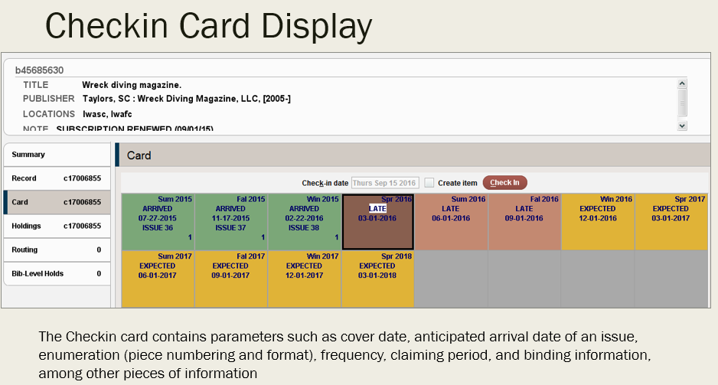

Patron facing clarity:
- Reveal both holdings and items in the catalog with greater detail
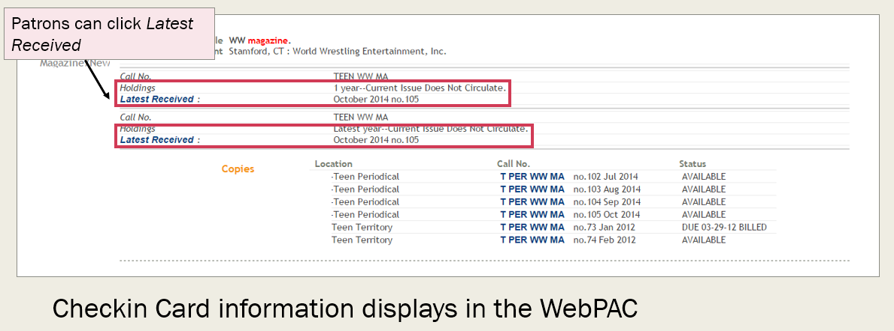
Routing: If a title is circulated to specific staff or patrons before display, you can automate this for better tracking.
Bindary: If the library sends items to bindary, the checkin cards can be used to group items and display as bound, based on information in the checkout record.

