Patron Images: **Difficulty level = Easy with cost\***

The Patron Images product allows library staff to store or link an image to the patron record for easier identification. The image is not actually stored in the record, it is merely linked through the record and stored in a file on the Sierra server. Once Patron Images is implemented, the window for patron’s images is an optional display in the top right corner of the record. The library can independently choose to add images to their patron records.

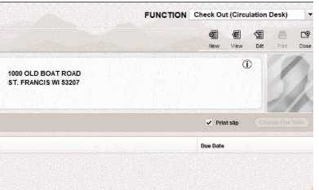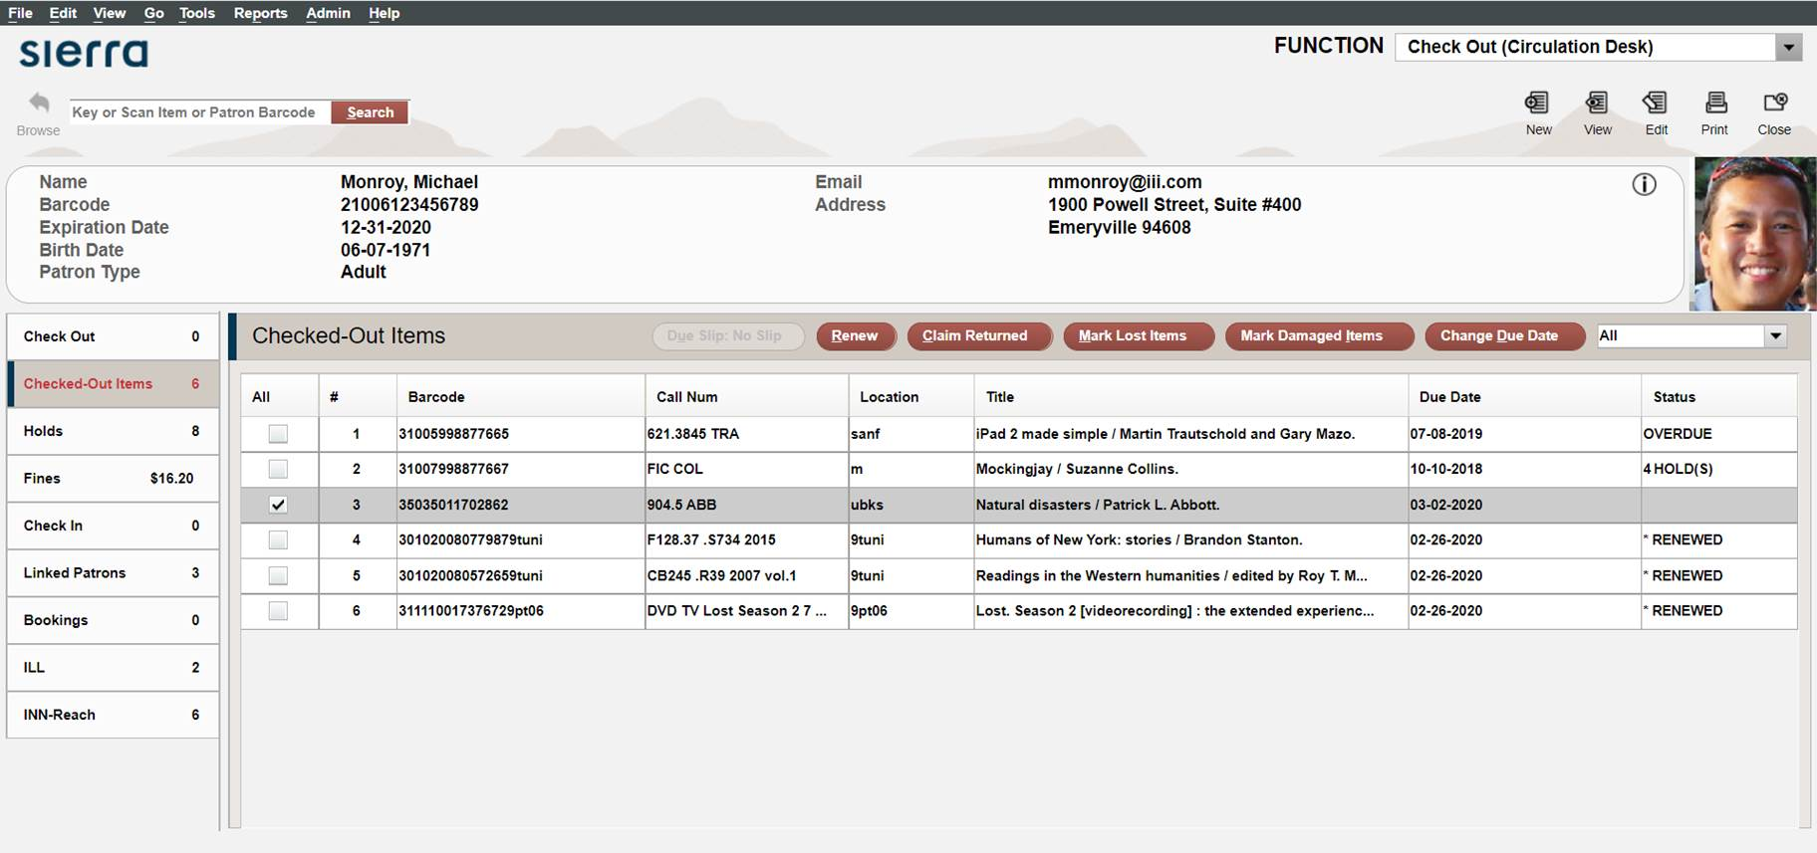

*The library will need to purchase a network ready Web camera that is connected to the internet. In the same way that a printer can be shared by many workstations, the camera can also be shared. Images are stored to the Sierra folder and then linked to the record.

Noteworthy downside: The display is enabled through the custom patron record display option in the user’s login. Enabling that display limits the patron summary to single column display.  
  
Taking a Patron's Picture

If your library acquired the [Internal Patron Images](https://csdirect.iii.com/sierrahelp/Content/sgcir/sgcir_camera_internal.html) product and you have access to a [camera](https://csdirect.iii.com/sierrahelp/Content/sgcir/sgcir_camera_hardwarereqs.html) and a [properly configured photo station](https://csdirect.iii.com/sierrahelp/Content/sgcir/sgcir_camera_setcameraoptions.html), you can take a patron's photograph while using certain functions.

To take a patron's photograph:

1. Ensure that the **Show patron photograph** [Patron Display option](https://csdirect.iii.com/sierrahelp/Content/sadmin/sadmin_useraccts_auths_users_options_patron_display.html) is enabled for the login.
2. Choose one of the following functions from the **Function** list:
   * **Circulation Desk**
   * **Count Use - Photocopies by Patron**
3. [Retrieve](https://csdirect.iii.com/sierrahelp/Content/sgcir/sgcir_patron_retrievingapatron.html) the patron record.

Sierra displays the patron photograph area in the patron display window. If the patron record already contains a photograph, the system displays the patron's photograph. Otherwise, the system displays a blank patron photograph area.

For example:



1. Ask the patron to stand in front of the camera.
2. When the patron is ready, click on the patron photograph area. The system displays the camera's current view and prompts you to take a picture.
3. To capture the currently displayed image, choose **Take Picture**. The system displays the image that you just captured.
4. If you want to take another picture, choose **Retake Picture**. The system replaces the current image.
5. To save the current image for the currently displayed patron record, choose **Save**.

The system stores the images that you capture on your server.