Materials Booking: Difficulty level = Medium
With Materials Booking, you "book" or reserve library materials for patrons for their future use. Unlike holds, the time period during which the patron will have access to the booked item is specified when you place the booking. You can book bibliographic materials and other materials, such as audiovisual equipment and rooms. Items like museum passes or even study rooms can be booked in advance. Some sites even use the booking module to book appointments with experts or reference staff.
You can book materials for hours, days, weeks, and months. When you place a booking, you can configure Sierra to create additional bookings on the item at specified intervals. For example, you can configure Sierra to create additional bookings for the same time of day for a given number of days in a row or for the same day and time for a given number of weeks in a row. You can place up to 400 bookings on an item record or for a patron record.
With Materials Bookings, you can also create events that can be used to link the different bookings placed for a patron. For example, you might create an event to link all of the bookings associated with a professor's course. An event must be associated with a booking. However, a booking can be created without being associated with an event. An occurrence is a booking that is associated with an event. If multiple bookings are placed for the same patron, and share the same Start Date and event, they belong to the same occurrence.
Booking is possible at the item level and even at the title level. Circulation rules determine if an item is available for booking. Bookings are placed similarly to holds from the patron record or the item record.
In the patron record, bookings are managed in the same view as Holds. 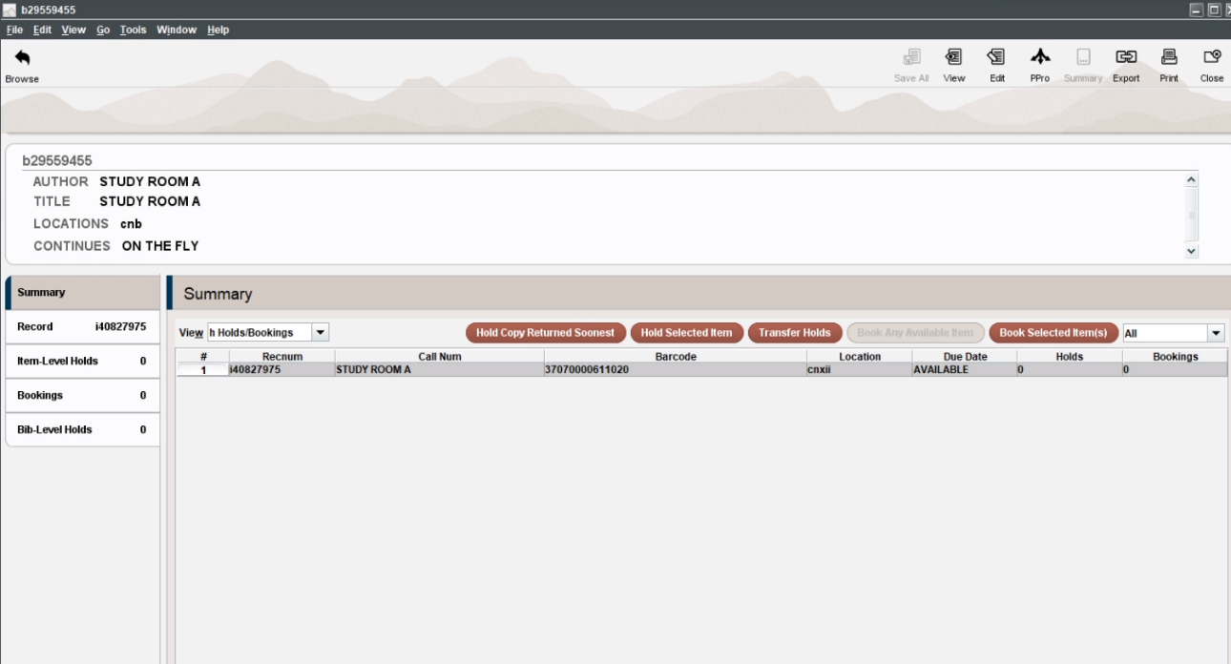
Patrons may also book items in Encore
