Mango – System Stats
Library stats for Mango are included int the WAM statistics report
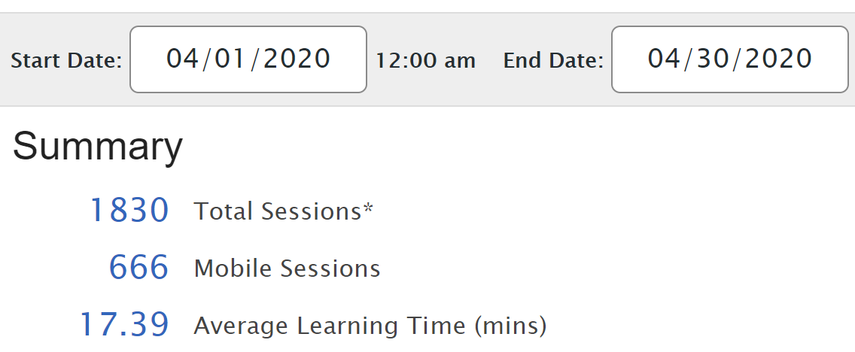
Language | Registered | Anonymous
Spanish, Latin American | 493 | 114
Italian | 213 | 18
Spanish for Librarians | 170 | 5
French | 122 | 18
Russian | 56 | 29
German | 45 | 30
Chinese, Mandarin | 71 | 1
Japanese | 60 | 5
ESL Spanish (Latin American) | 43 | 0
Hebrew, Biblical | 41 | 0
Polish | 28 | 1
Spanish, Castilian | 21 | 3
Ukrainian | 24 | 0
Portuguese (Brazil) | 14 | 5
Arabic, Levantine | 18 | 0
Yiddish | 13 | 2
Korean | 13 | 1
Hebrew | 12 | 0
Hindi | 11 | 1
Chinese, Cantonese | 11 | 0
Arabic, MSA | 10 | 0
Turkish | 10 | 0
Latin | 6 | 3
Pirate | 8 | 0
Scottish Gaelic | 5 | 2
Dutch | 5 | 0
ESL Russian | 4 | 1
Greek | 5 | 0
Slovak | 5 | 0
Swedish | 5 | 0
Vietnamese | 5 | 0
Arabic, Egyptian | 4 | 0
Cherokee | 4 | 0
ESL Korean | 2 | 2
Greek, Ancient | 3 | 1
Business English for Spanish | 3 | 0
Croatian | 3 | 0
Farsi | 3 | 0
Greek, Koine | 3 | 0
Romance, French | 3 | 0
Shakespearean English | 3 | 0
Telugu | 3 | 0
Thai | 3 | 0
Zodiac Signs, Mandarin | 3 | 0
Arabic, Iraqi | 2 | 0
Argot, French | 2 | 0
Armenian | 1 | 1
Business, Spanish | 2 | 0
Danish | 2 | 0
Haitian Creole | 2 | 0
Legal, Spanish | 2 | 0
Norwegian | 2 | 0
Romance, Spanish | 1 | 1
Romanian | 2 | 0
Shanghainese | 2 | 0
Tamil | 2 | 0
Urdu | 2 | 0
Bengali | 1 | 0
Chaldean Aramaic | 1 | 0
Dari | 1 | 0
ESL Arabic (Egyptian) | 1 | 0
ESL Greek | 1 | 0
Hawaiian | 1 | 0
Horse Race of Siena, Italian | 0 | 1
Hospitality & Tourism, Portuguese (Brazil) | 1 | 0
Hungarian | 1 | 0
Icelandic | 1 | 0
Indonesian | 1 | 0
Irish (Standard) | 1 | 0
Kazakh | 1 | 0
Mimetic Words, Japanese | 1 | 0
Oktoberfest, German | 0 | 1
Potawatomi | 1 | 0
Romance, Portuguese (Brazil) | 1 | 0
Serbian | 1 | 0
St Patrick's Day, Irish | 1 | 0
Superstition, Russian | 0 | 1
Swahili | 1 | 0
Text Talk | 1 | 0

