Mango – System Stats
Library stats for Mango are included int the WAM statistics report
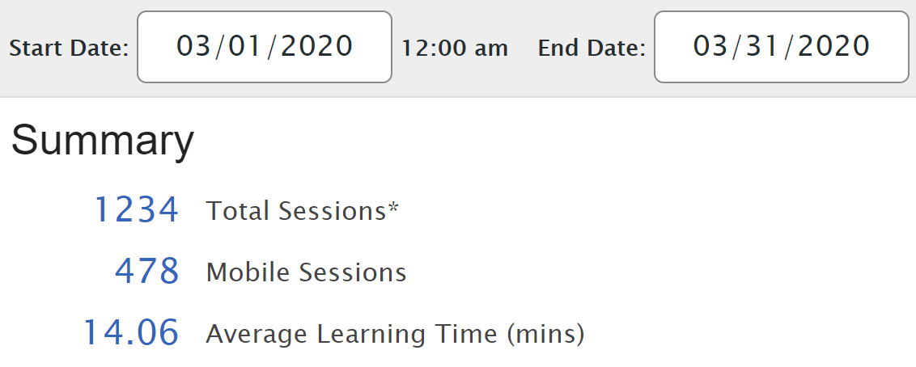
Course | Registered | Anonymous
Spanish, Latin American | 375 | 76
Italian | 113 | 30
French | 106 | 11
German | 81 | 6
ESL Spanish (Latin American) | 77 | 0
Chinese, Mandarin | 70 | 5
Japanese | 29 | 14
Russian | 35 | 3
Polish | 29 | 0
Portuguese (Brazil) | 25 | 0
Spanish for Librarians | 21 | 2
Spanish, Castilian | 21 | 1
Swedish | 16 | 0
ESL Russian | 11 | 0
Hebrew, Biblical | 11 | 0
Korean | 10 | 1
Ukrainian | 11 | 0
Arabic, Levantine | 10 | 0
Pirate | 9 | 1
Arabic, Egyptian | 7 | 0
Latin | 5 | 2
Hebrew | 6 | 0
Irish (Standard) | 5 | 1
Danish | 4 | 1
Greek | 4 | 1
Icelandic | 5 | 0
Chaldean Aramaic | 3 | 1
Croatian | 4 | 0
Dutch | 4 | 0
Slovak | 4 | 0
Swahili | 4 | 0
Telugu | 4 | 0
Turkish | 4 | 0
Chinese, Cantonese | 2 | 1
Farsi | 2 | 1
Greek, Ancient | 3 | 0
Hindi | 3 | 0
Oktoberfest, German | 3 | 0
St Patrick's Day, Irish | 3 | 0
Arabic, Iraqi | 2 | 0
Arabic, MSA | 2 | 0
Business, Spanish | 2 | 0
ESL Italian | 2 | 0
ESL Portuguese (Brazil) | 0 | 2
French, Canadian | 2 | 0
Haitian Creole | 1 | 1
Norwegian | 1 | 1
Scottish Gaelic | 2 | 0
Tagalog | 2 | 0
Tamil | 1 | 1
Thai | 2 | 0
Armenian | 1 | 0
Azerbaijani | 1 | 0
Bengali | 1 | 0
Cherokee | 1 | 0
ESL Arabic (Egyptian) | 1 | 0
ESL French | 0 | 1
ESL Spanish - Lenguaje de Text | 1 | 0
Finnish | 1 | 0
Hawaiian | 1 | 0
Hungarian | 0 | 1
Javanese | 1 | 0
Malayalam | 1 | 0
Medical, Spanish | 1 | 0
Potawatomi | 1 | 0
Punjabi (Pakistani) | 1 | 0
Romance, Spanish | 1 | 0
Romanian | 1 | 0
Shakespearean English | 1 | 0
Text Talk | 1 | 0
Urdu | 1 | 0
Uzbek | 1 | 0
Vietnamese | 1 | 0
Yiddish | 1 | 0
Zodiac Signs, Mandarin | 1 | 0

