Encore Harvesting: Difficulty level = easy / hard*
Requirements: To be eligible for harvesting, the digital resource must be OAI/PMH compliant and we must have legitimate access to the resources.
Background: Encore Harvesting uses an overnight process to import records from a digital repository in an overnight process. The records and their metadata are loaded and indexed in Encore. They are searchable and include direct links out to the actual source within the repository.
*Our Sierra Success Bundle includes 5 separate instances of harvesting. We have already installed harvesting and a sample of it is in place to review, so the implementation is very easy. The hard piece is deciding which resources should be included.
Sample: We have loaded a database owned by the Poughkeepsie Public Library District as an example. In Encore you can search for “trains”, or more specifically “first engine Connecticut” to review the records. Click the Media File button to access the image in the external digital repository.
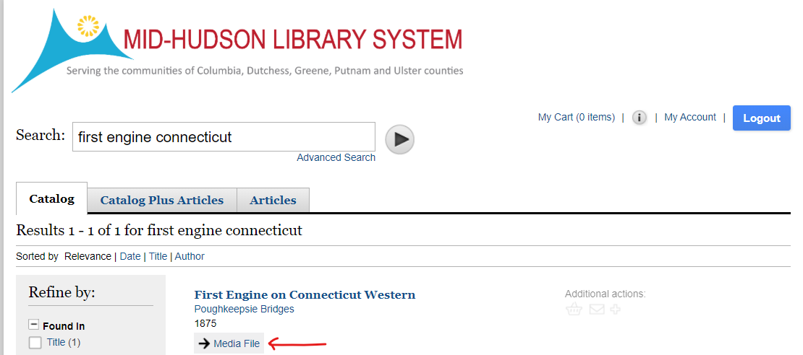
The image displays in a browser
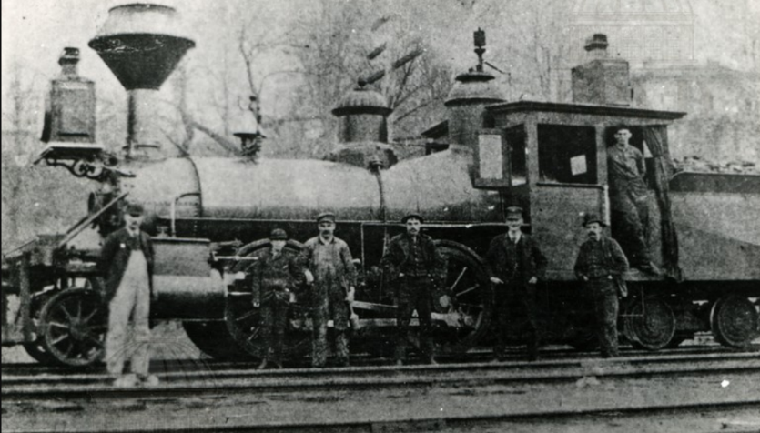
Note: 5 sources are included in our subscription, but more can be purchased. An example of an eligible source could be HRVH or NYheritage.

